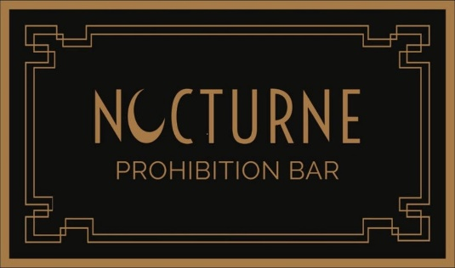

Signature Cocktails
Lychee Gone In Smoke
Gin, Lychee, Rose, Elderflower, Jasmine, Citrus, Ginger
15
Dragon Lady
Tequila, Bitter, Hibiscus, Lime, Red Pepper, Thai Chili, Dragonfruit
14.5
Savage Garden
Gin, Sake, Cucumber, Mint, Aloe Vera, Apple, Citrus, Elderflower
12.5
Clarified Punch – Nocturne
Blend of Rums, Green Tea, Pineapple, Calamansi, Tonka, Vanilla, Lime, Green Paint – All washed using Soya Milk
14.5
Apples & Pears
Choose between Vodka, Pisco, Tequila or Mezcal
Apple, Vanilla, Dry Sherry, Lemongrass, Peary
13.5
Afternoon Tea
Vodka, Pear, Earl Grey, Plum Wine, Cinnamon, Lotus
13
Bittersweet Highball
Pisco, Bitter, Pomegranate, Passion Fruit, Vanilla, Soda
15
Palm Court Club
Tepache, Chrysanthemum, Citrus, Prosecco
12
If you have any intolerances/Allergies, Please let know a member of our team.
All bills includes a discretionary 12.5% service Charge

